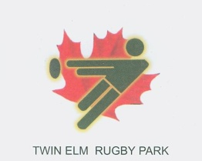
January 11, 2014 – TWIN ELM RUGBY PARK

ANNUAL GENERAL MEETING

AGENDA (DRAFT 2.1)

- Welcome and Introductions

- Roll Call and Call to Order

- Review of Previous Minutes
  - Business Arising

- Reports
  - President/Vice President
  - Clubs
  - Secretary
  - Finance
  - Facilities

- TERP Strategic Review
  - Vision, Mission, Goals, Objectives, Operations
  - Recommended Governance Model and Management Structure

- Election of Officers

- 2014 Plans
  - Activities based on Strategic Review
  - Finances
  - Management
  - Long-term Planning
  - New Sources of Revenue

- Other Business
  - WOSC
  - City of Ottawa
  - 40th Anniversary Plans
  - Other

